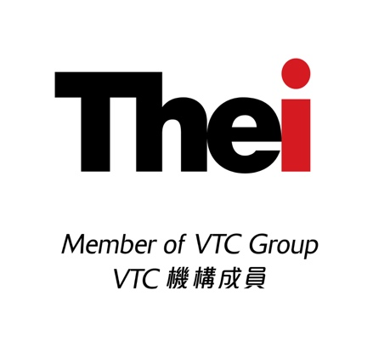
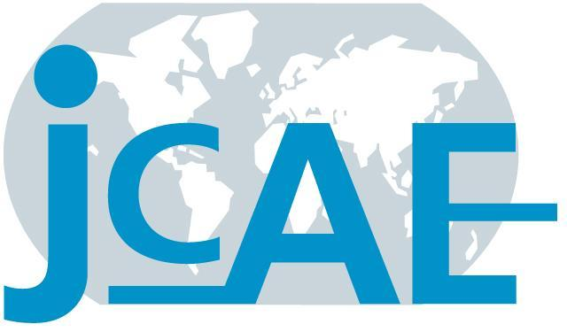

Faculty of Management and Hospitality
THEi

I/We would like to attend THEi Conference# on Business Sustainability and Corporate Governance – Performance, Reporting and Assurance scheduled for 23 – 24 June, 2016.
Enclosed is a crossed cheque made payable to “Technological and Higher Education Institute of Hong Kong” for the two-day Conference fee (HK$2,500 per person).

Name:

Address:

Firm: Position:

Professional Membership: Tel No.:

Email: Date:

Special Dietary Needs:

Signature:

Remarks:
Please return this form together with the cheque to Ms Zoe Law, Room KT166, 30 Renfrew Road, THEi, Kowloon Tong, Hong Kong.

